Department of Veterans Affairs

Innovation #665 Hazardous Pharmaceuticals

Installation Guide



September 2013

Version 1.0

Revision History

Date | Revision | Description | Author
09/13 | 1.0 | Original Version | Bob Thomas

(This page included for two-sided copying.)
Table of Contents
Innovation #665 Hazardous Pharmaceuticals ii
Revision History i
Introduction 1
Purpose 1
Before You Begin 1
Section 1: Installation of Oracle Database Setup 3
Scope 3
Audience 3
Installation 3
Prepare PPSNEPL schema for new hazard data elements 3
Prepare STERICYLCLE and NIOSH source data for loading 3
PPS-N Data load snapshot extraction for Vista Synchronization 4
Loading Hazard Data in VistA 9
Section 2: Installation of Java/J2EE Development Environment 11
Scope 11
Audience 11
Installation 12
Section 3: Web Logic Installation for Test Environment 23
Scope 23
Installation 23
Section 4: Installation for Vista Environment 29
Scope 29
Audience 29
Installation 29
Section 5: Installation of BCMA Modifications Environment 35
Pre-Installation Information 35
Installation Time Estimates 35
Resource Requirements 35
Response Time Monitor 36
Laptops and Bar Code Scanners 36
Printers 36
Unit Dose Label Printer Devices 36
IV Label Printer Devices 36
Client PC Setup Requirements 36
Files Required to Run BCMA V. 3.0 36
Routines Installed 37
Routine Mapping 37
Routines with Related Checksums 37
VistA Server Installation 39
Additional Preparation for BCMA V. 3.0 41
Installing PSB*3*68T25 BCMA Client Prototype 41

Introduction
The Innovation #665 Hazardous Pharmaceuticals project was developed from the Veterans Administration (VA) Innovation Program. Through this initiative, prospective projects submitted by VA employees examine for benefit, funding and development. Designated projects transition to the first of two innovation phases; a prototype phase, where the requested functionality is developed outside the VA Network in a virtual environment known as the VA Innovations Sandbox.

Every VA pharmacy in the country carries pharmaceuticals that present hazards for human exposure and environmental hazards upon disposal. Many VA pharmacies utilize automation. Hazardous pharmaceuticals should not be packaged or processed through automation allowing for cross contamination that would expose our Veteran population to risk unnecessarily. Nurses, in VA facilities across the country, administer medication utilizing the Bar Code Medication Administration (BCMA) system without knowing the potential for exposure hazards or the appropriate disposal methods. Facilities that improperly dispose of pharmaceuticals are subject to substantial Environmental Protection Agency (EPA) fines. This project has essential benefits for Veterans served by VA pharmacies, all VA staff who handle pharmaceuticals, the American taxpayer and the environment.

This source code and references within this document for this prototype should only be obtained from the Open Source Electronic Health Record Agent (OSEHRA) repository.

Purpose
The purpose of this Installation Guide is to provide an explanation of the installation steps to be followed to set up the test and development environment for the Oracle, Web Logic, PPS-N, VistA and BCMA application in order to implement the changes required for the Hazardous Pharmaceuticals innovation project.

Before You Begin
This document is organized into five major sections:
- Installation of Oracle Database Setup
- Installation of Web Logic Environment
- Installation of PPSN
- Installation for VistA Environment
- Installation of BCMA Modifications Environment

(This page included for two-sided copying.)

Section 1: Installation of Oracle Database Setup

Scope
Setup and installation of the Hazardous Pharmaceuticals prototype environment involves execution of a series of steps against an existing PPS-N database instance. The instruction given in this guide does not cover setup of the PPSNEPL schema. For instruction on setup and installation of the PPS-N database schema for the first time see the PPS-N Installation guide.

Audience
Setup and installation of the Hazardous Pharmaceuticals prototype database environment must be performed by a qualified Database Administrators (DBA) versed in the Oracle RDBMS and interfaces. The DBA must have SYSDBA privileges on the Oracle instance and database server on which the prototype is to be installed.

Installation
Following is a high-level description of the process needed to load hazardous to dispose and hazardous to handle data from STERICYCLE and NIOSH data sources identified for this prototype effort.
Installation of the Oracle Database Setup consists of the following:
- Prepare PPSNEPL schema for new hazard data elements
- Prepare STERICYCLE and NIOSH source data for loading
- Load Hazard Data in PPS-N Database
- Loading Hazard Data in VistA

Prepare PPSNEPL schema for new hazard data elements
Steps:
- Create 3 new fields to store Hazard to Dispose data
- Create entry in epl_vadf_nonlist_values table for each applicable field:
- primary.epa.code (string) (NEW)
- waste.sort-code (string) (NEW)
- dot.shipping.name (string) (NEW)
- Create 2 new input tables to store the STERICYCLE and NIOSH source data.

Prepare STERICYLCLE and NIOSH source data for loading
Loading – Hazard to Dispose
Steps:
- Input file Attachment-A_EPA.xls
- Export into flat file format (CSV-MSDOS)
- Create Hazard_Dispose_Input table
- Use SQL Loader to load dispose input data
  - [oracle@vaphs665orc2 Initial_Data_Load]$ sqlldr control=HazardousToDisposeCSVDOS.ctl skip=1
- Run stored procedure to load data and display results
- Review output

Loading – Hazard to Handle
Steps:
- Input file for website http://www.cdc.gov/niosh/docs/2012-150/pdfs/2012-150.pdf
- Convert input file to Excel (CSV/MSDOS) format.
- Load to Oracle using Oracle’s IMPORT (SQL Loader) utility into an input table
- [oracle@vaphs665orc2 Initial_Data_Load]$ sqlldr control=HazardousToHandleCSVDOS.ctl skip=1Run a stored procedure that implements the matching algorithm and updates the EPL_VADF_NONLIST_VALUES and EPL_VADF_OWNERS

Note: Please see the PPS-N version 1.0 Installment Guide for complete installation instructions. Use the below link to reference the document.
http://www.va.gov/vdl/application.asp?appid=202
http://www.va.gov/vdl/documents/HealtheVet/Pharm_Product_System_National/pren_1_ig.pdf

PPS-N Data load snapshot extraction for Vista Synchronization
After the PPS-N Enterprise Product List Database (EPL DB) has been loaded with the hazardous to handle and hazardous to dispose information from the NIOSH and STERICYCLE data sources, the following steps are needed to ensure that the database updates are reflected in Vista:
Steps
- Run the PPS-N Database snapshot script:
This step needs to be executed by the Database Administrator (DBA) of the PPS-N EPL DB.
The script that needs to be run executes the following SQL. This SQL statement may be copied into a TOAD editor window and executed from TOAD.

select * from
(select
hthTbl.ndfIen as ndf_ien,
hthTbl.productName as product_name,
hthTbl.hth as haz_to_handle,
htdTbl.htd as haz_to_dispose,
pepaTbl.pepa as primary_epa_code,
wscTbl.wsc as waste_sort_code,
shipNameTbl.shipName as shipping_name
from
(select
PRODUCTS.NDF_PRODUCT_IEN ndfIen,
PRODUCTS.VA_PRODUCT_NAME productName,
NLVS.VA_DF_VALUE as hth,
NLVS.VADF_OWNER_ID_FK ownerId,
OWNERS.EPL_ID_PRODUCT_FK productId
from
EPL_VADF_NONLIST_VALUES nlvs join EPL_VA_DFS vadfs on NLVS.VADF_ID_FK=VADFS.ID
join EPL_VADF_OWNERS owners on NLVS.VADF_OWNER_ID_FK=OWNERS.ID
join EPL_PRODUCTS products on OWNERS.EPL_ID_PRODUCT_FK = PRODUCTS.EPL_ID
where VADFS.ID = 35 ) hthTbl
join
(select
PRODUCTS.NDF_PRODUCT_IEN ndfIen,
PRODUCTS.VA_PRODUCT_NAME productName,
NLVS.VA_DF_VALUE as htd,
NLVS.VADF_OWNER_ID_FK ownerId,
OWNERS.EPL_ID_PRODUCT_FK productId
from
EPL_VADF_NONLIST_VALUES nlvs join EPL_VA_DFS vadfs on NLVS.VADF_ID_FK=VADFS.ID
join EPL_VADF_OWNERS owners on NLVS.VADF_OWNER_ID_FK=OWNERS.ID
join EPL_PRODUCTS products on OWNERS.EPL_ID_PRODUCT_FK = PRODUCTS.EPL_ID
where VADFS.ID = 34 ) htdTbl
on htdTbl.ndfIen=hthTbl.ndfIen
left join
(select
PRODUCTS.NDF_PRODUCT_IEN ndfIen,
PRODUCTS.VA_PRODUCT_NAME productName,
NLVS.VA_DF_VALUE as pepa,
NLVS.VADF_OWNER_ID_FK ownerId,
OWNERS.EPL_ID_PRODUCT_FK productId
from
EPL_VADF_NONLIST_VALUES nlvs join EPL_VA_DFS vadfs on NLVS.VADF_ID_FK=VADFS.ID
join EPL_VADF_OWNERS owners on NLVS.VADF_OWNER_ID_FK=OWNERS.ID
join EPL_PRODUCTS products on OWNERS.EPL_ID_PRODUCT_FK = PRODUCTS.EPL_ID
where VADFS.ID = 149 ) pepaTbl on htdTbl.ndfIen=pepaTbl.ndfIen
left join
(select
PRODUCTS.NDF_PRODUCT_IEN ndfIen,
PRODUCTS.VA_PRODUCT_NAME productName,
NLVS.VA_DF_VALUE as wsc,
NLVS.VADF_OWNER_ID_FK ownerId,
OWNERS.EPL_ID_PRODUCT_FK productId
from
EPL_VADF_NONLIST_VALUES nlvs join EPL_VA_DFS vadfs on NLVS.VADF_ID_FK=VADFS.ID
join EPL_VADF_OWNERS owners on NLVS.VADF_OWNER_ID_FK=OWNERS.ID
join EPL_PRODUCTS products on OWNERS.EPL_ID_PRODUCT_FK = PRODUCTS.EPL_ID
where VADFS.ID = 150 ) wscTbl on htdTbl.ndfIen=wscTbl.ndfIen
left join
(select
PRODUCTS.NDF_PRODUCT_IEN ndfIen,
PRODUCTS.VA_PRODUCT_NAME productName,
NLVS.VA_DF_VALUE as shipName,
NLVS.VADF_OWNER_ID_FK ownerId,
OWNERS.EPL_ID_PRODUCT_FK productId
from
EPL_VADF_NONLIST_VALUES nlvs join EPL_VA_DFS vadfs on NLVS.VADF_ID_FK=VADFS.ID
join EPL_VADF_OWNERS owners on NLVS.VADF_OWNER_ID_FK=OWNERS.ID
join EPL_PRODUCTS products on OWNERS.EPL_ID_PRODUCT_FK = PRODUCTS.EPL_ID
where VADFS.ID = 151 ) shipNameTbl on htdTbl.ndfIen=shipNameTbl.ndfIen ) t
where t.haz_to_handle='true' or t.haz_to_dispose='true' order by t.product_name ASC;

- Export of TOAD Dataset into a Delimited file:
Using the Export Dataset functionality of TOAD editor, generate a delimited file of the query output. Select any cell of the data grid showing the results of the query and right click. This should bring up a menu as shown below. Select the “Export Dataset” option.
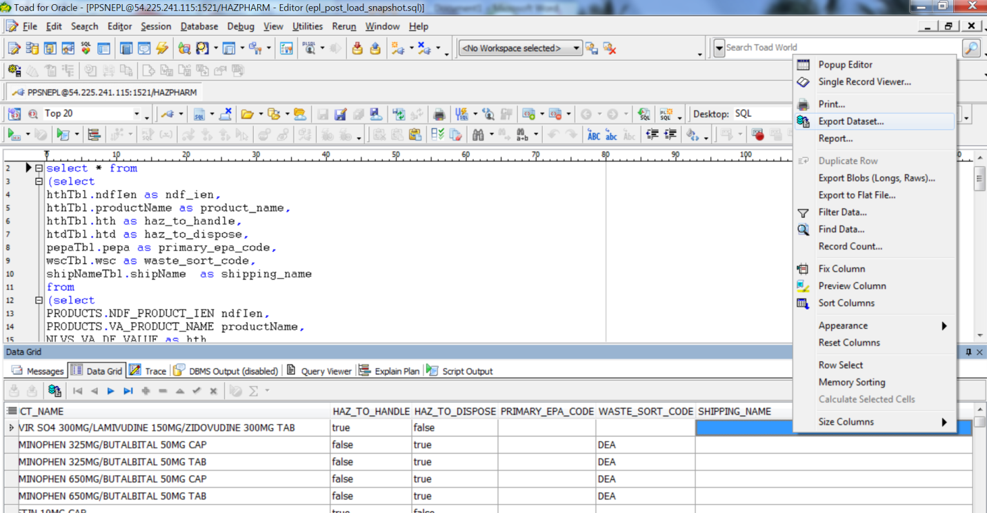
When clicking on the Export Dataset option, the following popup window should display: Select “Delimited Text” for Export format.
Ensure that the “Options” tab has selections similar to those shown below.
Note: Pipe is used as a Delimiter. “Include column headers” is not selected. The csv extension is used for the file being created.

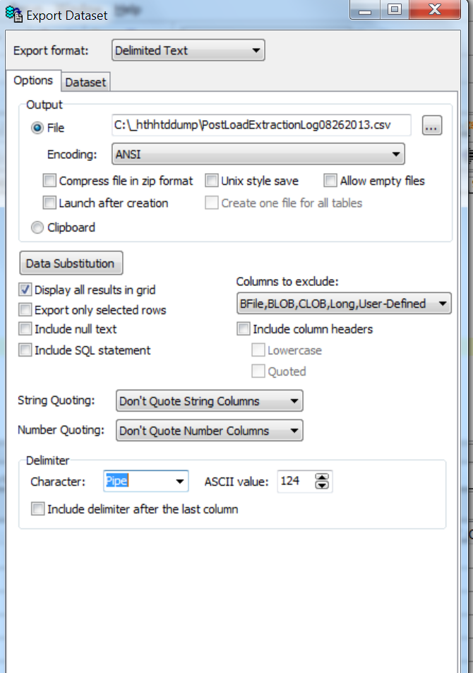
- Submit the Export request and view the snapshot file created:
Select OK in the “Export Dataset” pop up window:
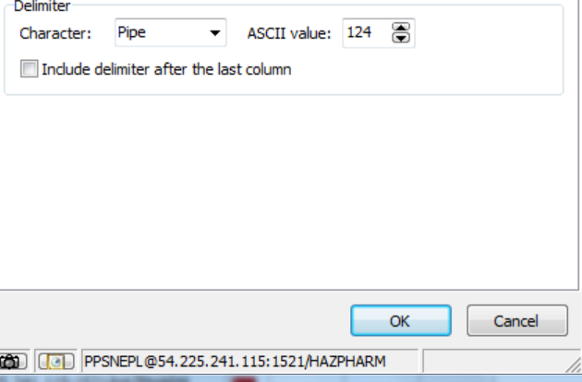

This starts the export process. You will see a running counter of the number of rows exported in the “Export Dataset” pop up window progress bar as shown below :

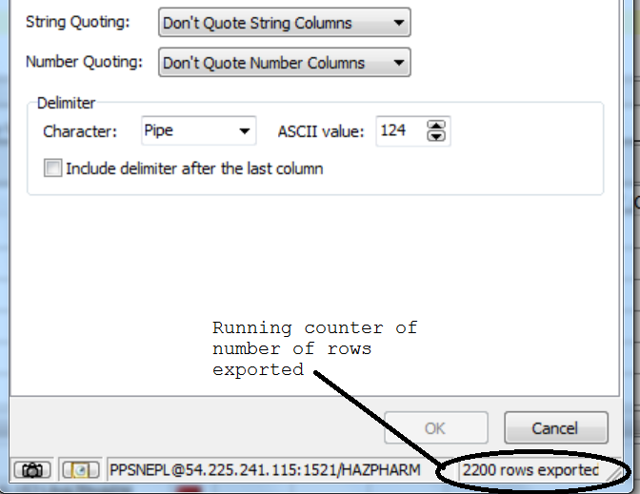
- Adding an End of Transmission (EOT) string in the exported file:
When the “Export Dataset” popup window closes, open the CSV file using a text editor such as Notepad+.
Go to the last row and add the eot character or just type in “EOT” as the last line in the file.

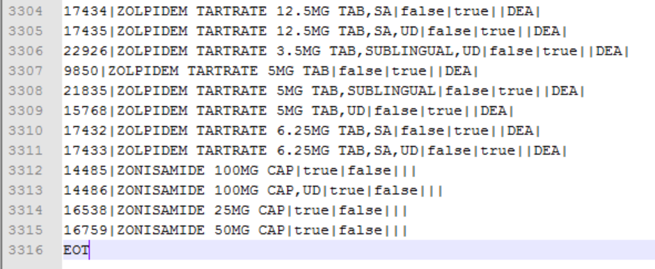
The file is now ready for transmission to the VistA server. The data elements in each row are in the following order:
  - The Product file IEN key that is used to synchronize changes for the specific product between PPS-N and VistA.
  - The VA product name
  - The Hazardous to Handle flag (true implies the drug is hazardous to handle)
  - The Hazardous to Dispose flag (true implies the drug is hazardous to dispose)
  - The Primary EPA Code
  - The Waste Sort Code
  - The DOT Shipping Name
These data elements are separated in the file by the Pipe delimiter. There should be one line in the file exported for each drug (VA product) in PPS-N EPL DB that has been marked up as either Hazardous to handle, Hazardous to dispose, or both.
- Provide the exported file to the VistA System administrator:
This step can be performed as recommended by the System administrator of the VistA system hosting the National Drug file data. The file may be FTP’d over to a specific location as provided by the system administrator. The file is subsequently picked up by a MUMPS data loading routine on the VistA side which can apply these changes to the VistA National Drug file.

Loading Hazard Data in VistA
Steps:
- Enter menu option PSS DRUG HAZARD LOAD
- Enter the filename of the extract file that was FTP’d over from PPS-N
- Please note, for this innovation, the file directory is defaulted to d:\intersystems\cache\mgr\dev1
- If there are mismatches encountered during the data load, these will create a Mismatch report.
- The Mismatch report file name will appear on the screen after the data load has been completed.
- The data load is completed.
Example: VistA Data Load
Setting up programmer environment
This is a TEST account.

Terminal Type set to: C-VT320

You have 235 new messages.
Select OPTION NAME: PSS DRUG HAZ
1 PSS DRUG HAZARD ENTER/EDIT Hazardous Drug Enter/Edit
2 PSS DRUG HAZARD LOAD Hazardous Drug Data Load
3 PSS DRUG HAZARD LOOKUP Hazardous Drug Lookup
4 PSS DRUG HAZARD MISMATCH Hazardous Drug Mismatch Report
5 PSS DRUG HAZARD RESET Hazardous Drug Local Mod Flag Reset
CHOOSE 1-5: 2 PSS DRUG HAZARD LOAD Hazardous Drug Data Load
Hazardous Drug Data Load
Enter the name of the file: PPSN_EXTRACT_08092013_AFTERRELOAD.TXT
Do you want to see the file information scroll on the screen? N

You have VA PRODUCT NAME mismatches.
Look for the file named "Mismatch_Report_6304568633.txt"
in your default directory.

Running Mismatch report in VistA

Steps to run the Mismatch report
- Enter menu option PSS DRUG HAZARD MISMATCH
- Enter the filename of the Mismatch report.
- The mismatches will appear on the screen.
- The Mismatch report is completed.
Example: Running Mismatch Report
Select OPTION NAME: PSS DRUG HA
1 PSS DRUG HAZARD ENTER/EDIT Hazardous Drug Enter/Edit
2 PSS DRUG HAZARD LOAD Hazardous Drug Data Load
3 PSS DRUG HAZARD LOOKUP Hazardous Drug Lookup
4 PSS DRUG HAZARD MISMATCH Hazardous Drug Mismatch Report
5 PSS DRUG HAZARD RESET Hazardous Drug Local Mod Flag Reset
CHOOSE 1-5: 4 PSS DRUG HAZARD MISMATCH Hazardous Drug Mismatch Report

Hazardous Drug Mismatch Report

This report will show any mismatches between the
PPS-N Data Load file and the VA PRODUCT File (#50.68).
Please note - this file may contain products that look
identical, but the entry may contain additional spaces
or other hidden control characters causing the mismatch.

Mismatch Report for VA PRODUCT NAMES Between PPS-N and VistA

VA PRODUCT IEN NUMBER: 14597
PPS-N VA PRODUCT NAME: GANIRELIX ACETATE 250MCG/0.5ML SYR INJ
VISTA VA PRODUCT NAME: GANIRELIX ACETATE 250MCG/0.5ML SYR INJ

VA PRODUCT IEN NUMBER: 23378
PPS-N VA PRODUCT NAME: DIGOXIN 0.06MG/ML ELIXIR
VISTA VA PRODUCT NAME: LARYNGECTOMY TUBE,SZ 11 BIVONA #BOSL3S

Section 2: Installation of Java/J2EE Development Environment

Scope
This section covers the setup of the development environment used for the Java/J2EE portion of the PPS-N application.
The components this part of the document covers include the setup of the IDE (Eclipse), build tools (ant) , the deployment server (BEA WebLogic) and the database browse client (TOAD).
Installation of the dependencies such as the Oracle Database and VistaLink Vista side configuration are covered later in the document.

Audience
This section is intended for Java developers with some level of familiarity with the tools being downloaded and installed.
Note: Please note that the Installation guide made available to the team DID NOT cover either the setup of the development environment or the building of the pps.ear from the source for PPS-N.
The following instructions are those that were utilized to generate a deployable ear file from the source after some reverse engineering of the build scripts provided with the source.

Installation
Installation Steps:

- Obtain Persistent Desktop access:
A Persistent VM image is used as the development sandbox. This sandbox is hosted in a private network inside the amazon cloud for VA innovation projects.
The persistent desktop image is requested from http://help.vacloud.us:8080/helpdesk/WebObjects/Helpdesk.woa
The specification of the image used:
Windows XP SP3 running on Intel Xeon 2.5 GHz with 3 Gigs RAM
- JDK installation:
Download and install JDK 1.6_041 from http://www.oracle.com/technetwork/java/javasebusiness/downloads/java-archive-downloads-javase6-419409.html
Select defaults for all install prompts.
- Eclipse installation:
Download the Eclipse IDE from http://www.eclipse.org/downloads/packages/release/indigo/sr2
The “Eclipse IDE for Java EE Developers” bundle is to be downloaded and installed. Post installation; ensure that the Java compiler level is set to 1.6 via Window/Preferences/Java/Compiler.
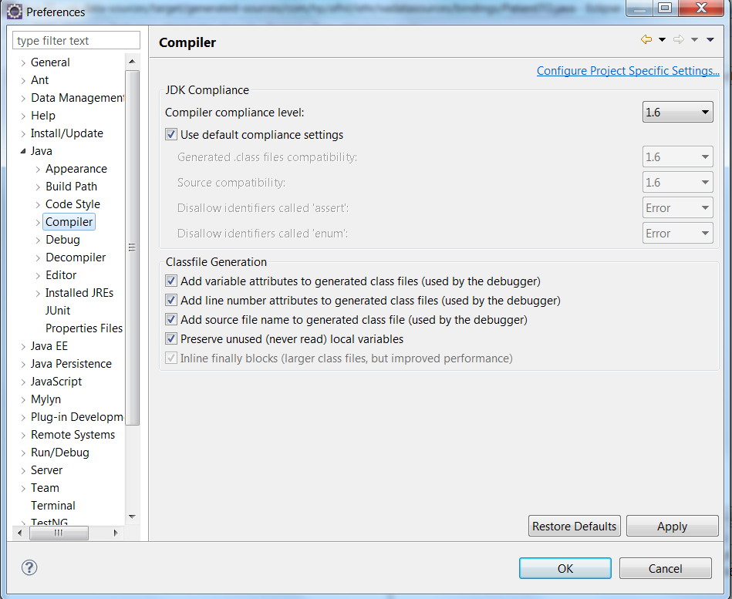
- Ant installation:
Install Ant version 1.7.1 from http://archive.apache.org/dist/ant/binaries/
The link above allows a download of a zip archive (bin.zip).
Unzip the archive into a folder on the hard drive and update ANT_HOME and PATH variables to ensure that ant –version can be called from a command line.
Note: PPS-N’s build scripts use some “features” of ant that are available in 1.7.1 but not available in later releases. Therefore an older version of ant is used for the installation despite the general recommendation on the apache site to use the latest Ant release

.

To get the ant scripts to work with the later versions – if so desired - a modification is needed in one of the build files that will be called out in a later step.

- PPS-N source code download:
The source for the production version of PPS-N as of early March 2013 was obtained from an internal wiki site maintained by VA’s development team for PPS-N.
http://129.162.104.73/index.php/Pharmacy:Latest_CODE_RELEASES
The following download bundle was used:

PPS-N Version 1.0 (2013-01-16)-production.zip
Upon unzipping the archive, PS_PPS_Bld and PS_PPS_Dev folders are obtained that include the source for the application, the ant build scripts and the DDL scripts for generating the EPL Database schema.
Note: An effort to obtain a more “official” source code download location such as Clear Case source repository wasn’t successful. Since the source was downloaded from an internal team wiki site, it is assumed here, based on the label of the downloaded archive, that the source obtained for PPS-N reflects what’s been deployed into production.
- BEA Weblogic installation and domain creation:
Per the Installation Guide for PPS-N v1.1:
“The installation instructions found within this guide are intended to be performed on a clean installation of WebLogic 10.3.2”
Note: BEA Weblogic 10.3.2 is not available on Oracle’s website for download:
http://www.oracle.com/technetwork/middleware/weblogic/downloads/wls-main-097127.html
The earliest available version is 10.3.3.
To work around this obstacle, a version of the 10.3.2 installer used on another project at VA is used to install the required BEA version.
After installing BEA Weblogic (all defaults selected on all install windows), a domain is created using the configuration assistant. The domain is called PRE and the domain is located physically on the path C:\Oracle\Middleware\user_projects\domains\PRE
- PPS-N Eclipse project import:
The downloaded source code comes with pre-configured Eclipse .project/.classpath files – i.e. the source package is ready for import into the Eclipse IDE as existing projects.
Once the source is unzipped into a location, using Eclipse > File > Import > General > Existing Projects into Workspace, select Root as the directory where the PS_PPS_Bld and PS_PPS_Dev folders reside.
This should bring in 7 Eclipse projects as shown below:

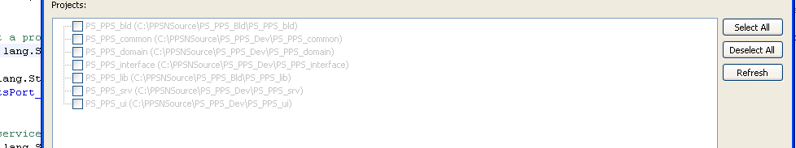
Select all of the projects and continue with the import.
Note: The source will not build initially since there is a package in PS_PPS_interface (gov.va.med.pharmacy.peps.external.common.vo.outbound) that’s generated when the build scripts are run from an XML Schema document using JAXB.
Therefore, when the source code is initially imported into Eclipse, the PS_PPS_interface project will not compile in Eclipse. The missing gov.va.med.pharmacy.peps.external.common.vo.outbound.* packages and the classes within them will be generated during the build process. So, for the time being, please ignore these errors reported by Eclipse.
- Source changes to work around dependencies on FSS and VETS:
Stubbing the FSS dependency:
PPS-N has a dependency on FSS which is a third party database that includes pricing information for drugs.
The existing SQL Server based FSS database instances in the VA network are not accessible from the sandbox in the cloud. There are no instructions available for the FSS database setup in the PPS-N Installation Guide.
Based on reverse engineering of the source code, the following options are identified for stubbing the FSS dependency for the innovation project:
Options:
  - Using hardcoded data values returned via a configured Java Stub class:
There is a stub class that simulates returning three products from FSS. The stub class is gov.va.med.pharmacy.peps.external.common.fss.outbound.capability.FssInterfaceCapabilityStub and can be used if a database connection to FSS is not available. Some of the Spring configuration files are already configured to utilize this stub class from a unit testing perspective.

To use the Stub instead of the Datasource based fetch of FSS data , the following change was made in the InterfaceContextTemplate.xml spring descriptor under PS_PPS_Interface\etc\xml\spring folder:
<!--
<bean id="fssInterfaceCapability" class="gov.va.med.pharmacy.peps.external.common.fss.outbound.capability.impl.FssInterfaceCapabilityImpl" autowire-candidate="true">
</bean>
-->

<bean id="fssInterfaceCapability" class="gov.va.med.pharmacy.peps.external.common.fss.outbound.capability.FssInterfaceCapabilityStub" autowire-candidate="true">
</bean>
The issue with the above option is that addition of any test data for pricing of the drugs requires a recompilation and rebuilding/redeploying of the PPS-N ear file.

  - Create a version of the FSS database with just the tables PPS needs: (Documenting here if there is a need to fall back to a different option):
Only 4 tables and 25 columns of the source code are being used. A database with just those tables and columns can be created for use for development and testing. This database can be Oracle, SQL Server or whatever database is available in the sandbox since basic SQL and JDBC calls are being used.
The identified tables/columns are as follows. These need to be created in a database. The Datasource within BEA for FSS must be set up to point to this configured Database.
Table: DI_DRUGITEMNDC

Columns:
DRUGITEMNDCID ID column (NUM)
FDAASSIGNEDLABELERCODE CHAR
PRODUCTCODE CHAR
PACKAGECODE CHAR
LastModificationDate DATETIME
CREATIONDATE DATETIME

Table: DI_DRUGITEMS

Columns:
DRUGITEMID ID column (NUM)
COVERED CHAR
PRIMEVENDOR CHAR
DRUGITEMNDCID NUM FK to DI_DRUGITEMNDC.DRUGITEMNDCID
CONTRACTID NUM FK to DI_CONTRACTS.CONTRACT_ID
LastModificationDate DATETIME
CREATIONDATE DATETIME

Table: DI_CONTRACTS

Columns:
CONTRACTID ID column (NUM)
CONTRACTNUMBER CHAR
DRUGITEMID FK to DI_DRUGITEMS.DRUGITEMID
LastModificationDate DATETIME
CREATIONDATE DATETIME

Table: DI_DRUGITEMPRICE

Columns:
isFss BIT (boolean)
isBig4 BIT (boolean)
isVa BIT (boolean)
pricestopdate DATETIME
price NUM(10,2)
DRUGITEMID FK to DI_DRUGITEMS.DRUGITEMID
LastModificationDate DATETIME
CREATIONDATE DATETIME
Find the FSS DDL scripts and create the complete FSS database/load Data needed for testing.
This is the most time and effort consuming option. Since only a subset of the complete database is used in the PPS-N application (based on the reading of the source), this might be overkill for the Hazardous pharmaceutical innovation project.
The least time consuming workaround to try to implement was Option 9.1 (Using hardcoded values returned via a configured stub class). Since the PPS-N changes that are in scope for the Hazardous pharmaceutical project are not directly related to the drug prices, this option was selected as a path of least resistance and effort.
  - Stubbing the VETS dependency:
VETS is a Standard Terminology web service used to pull in the standard Medical Administration Routes for drugs. The VETS web service is behind the VA firewall and therefore is not accessible from our sandbox. However, we do have a Stub (gov.va.med.pharmacy.peps.external.common.sts.outbound.capabilit.StsInterfaceCapabilityStub) that is available that we can use for our prototype. This stub returns hardcoded standard Medical Admin Routes.
The following needs to be added to the PS_PPS_Interface\etc\xml\spring\InterfaceContext.xml file to force it to use the Stub instead of the VETS service.
<bean id="stsInterfaceCapability" class="gov.va.med.pharmacy.peps.external.common.sts.outbound.capability.StsInterfaceCapabilityStub" autowire-candidate="true">
</bean>

- PPS-N source building with ant:

No documentation is provided on how to generate an ear file from the source using the ant scripts. The build scripts provided were reverse engineered to understand the build process.
Note: The ant scripts provided with the source dump were broken and wouldn’t replace the hibernate configuration properties as expected in the domain.xml (PS_PPS_DOMAIN/etc/build/template).
The following property (commented out) is changed, as follows, to get a deployable ear file:
<!—BROKEN !!!! <hibernatecfg destDir="@{destDir}"
dialect="${@{environment}.hibernate.dialect}"
dataSource="datasource/@{datasource}"
transactionManagerLookup="${@{environment}.transaction.lookup}"
transactionManagerFactory="${@{environment}.transaction.factory}"
showSql="${@{environment}.hibernate.show_sql}"
useOuterJoin="false"
version="3.0"> -->

<hibernatecfg destDir="@{destDir}"
dialect="org.hibernate.dialect.OracleDialect"
dataSource="datasource/@{datasource}"
transactionManagerLookup="org.hibernate.transaction.WeblogicTransactionManagerLookup"
transactionManagerFactory="org.hibernate.transaction.CMTTransactionFactory"
showSql="false"
useOuterJoin="false"
version="3.0">
Note: A property file that provides the site number property (the override for the 999 site number for the application) was missing from the source bundle.
This property file (gov.va.med.pharmacy.peps.siteConfig.properties) provides the prefix for some primary keys in the table (e.g. user records).
To avoid this problem, a value of 999 is returned from the getSiteNumber API of EnvironmentUtilityImpl class.
Note: If building with ant version 1.9.x a change is required in one of the provided template files (init.xml).
A conditional execution in that template file must be made unconditional as follows :
<target name="initTasks" unless=”init.ignore.Tasks”>
had to be changed to..
<target name="initTasks">
Navigate to C:\PPSNSource\PS_PPS_Bld\PS_PPS_bld in a command line and execute
ant -Ddeploy.environment=t1rack ear -Ddatabase.url.port=1521 -Ddatabase.url.port.suffix=: >antOut.txt
This results in the ear file being generated from the source.
The PS_PPS_Dev folder has the different modules that make up the PPS project. These different modules (Common, Domain, Interface, Services, UI) have interdependencies that are resolved by the ant scripts, and the different modules are built in the right order to finally create the single ear file for deployment.

- VistaLink setup:
  - For VistaLink setup, a jar file VistaLinkOptLib-1.6.jar containing the VistaLink jar and all its required dependencies (VistaLinkFoundations.jar and log4j.jar) is constructed.
  - Place this jar under C:\vistalinkdeployment\vistalink on the hard drive.
  - The vistaLinkOptLib-1.6.jar is then deployed as a standalone library using the BEA Weblogic Administration console.
  - A file called gov.va.med.vistalink.connectorConfig.xml is placed under the folder C:\vistalinkdeployment\vistalink\class_path.
This file has the Access and Verify code for the Vista link connector proxy user and the IP address and port for the M Listener.
  - The setDomainEnv.bat script for the Weblogic domain is modified to include the path to the class_path folder above.
if NOT "%EXT_PRE_CLASSPATH%"=="" (
if NOT "%PRE_CLASSPATH%"=="" (
set PRE_CLASSPATH=%EXT_PRE_CLASSPATH%;%PRE_CLASSPATH%
) else (
set PRE_CLASSPATH=%EXT_PRE_CLASSPATH%
)
)

set PRE_CLASSPATH=%PRE_CLASSPATH%;C:\vistalinkdeployment\vistalink\class_path;C:\beaclasspathprefix;C:\beaclasspathprefix\log4j-1.2.15.jar;C:\Oracle\Middleware\user_projects\domains\PRE\kajee_stage

if NOT "%EXT_POST_CLASSPATH%"=="" (
if NOT "%POST_CLASSPATH%"=="" (
set POST_CLASSPATH=%POST_CLASSPATH%;%EXT_POST_CLASSPATH%
) else (
set POST_CLASSPATH=%EXT_POST_CLASSPATH%
)
)
  - An ear file is constructed that includes the Resource Adapter Archive (RAR) for the connector itself. The ear file is deployed as an application onto the BEA weblogic domain created earlier.
- KAAJEE setup:
KAAJEE is used for the authentication and authorization against VISTA of the users logging into the PPS_N Interface.
KAAJEE is installed and configured using instructions provided in this document for Windows:
https://www.google.com/url?sa=t&rct=j&q=&esrc=s&source=web&cd=1&cad=rja&ved=0CDMQFjAA&url=http%3A%2F%2Fwww.va.gov%2Fvdl%2Fdocuments%2FInfrastructure%2FKAAJEE%2Fkaajee_1_0_0_019_installguide.doc&ei=fRx4UbGgAoGq2gWa0IGQBQ&usg=AFQjCNHizGd-5hOb4gKCtloW4IuoRz2WRg&bvm=bv.45580626,d.b2I
- TOAD installation:
TOAD is installed and set up using the instructions provided in the following document:
PROCEDURES FOR OBTAINING
QUEST Toad DEVELOPMENT SUITE WITH DBA MODULE FOR ORACLE
QUEST Toad DEVELOPMENT SUITE FOR SQL SERVER
FROM THE
VA ENTERPRISE LICENSE AGREEMENT

January 2012
VERSION 2.0
Before installing TOAD, the oracle client for windows must be installed from:
http://www.oracle.com/technetwork/topics/winsoft-085727.html

- BEA Weblogic domain configuration following the installation guide:
All the instructions in the PPS-N Installation guide from 3.6.1 to 3.6.6 are followed to configure the Datasources, the Log4j , the JTA settings and the JDBC driver dependencies.

- PPS-N ear deployment:
The PPS-N ear created from the source after the workaround for stubbing VETS and the FSS
Database is deployed to the WebLogic server using instructions in section 3.6.8 in the PPS-N install guide.

- PPS-N application testing after deployment:
IE is launched – and the following address is requested: http://<Deployment Machine>:<Deployment Server Port>/PRE/
In the case of the development VM, the URL is http://localhost:7001/PRE/
This displays the PPS-N login page as shown below :

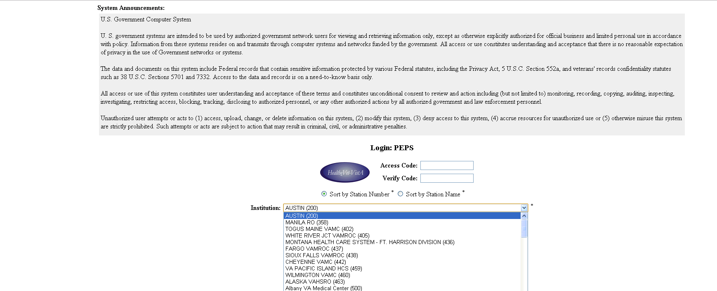
PPS-N uses KAAJEE for authenticating users of the PPS-N application against VistA. KAAJEE is also used to query the security keys assigned to a VistA account – depending on the security keys assigned or not assigned to the VistA account being used to login. Specific functions may be visible/enabled OR invisible/disabled. Before attempting to login into the application, please contact your VistA system administrator and have him/her create the appropriate security key for the role you plan to use when logging in. For development purposes, we recommend at least having the VistA security key PSS_PPSN_SUPERVISOR granted to the VistA account being used. This grants the VistA account Supervisor access in PPS-N which allows them to perform most operations required for the HazPharma innovation project. (Note that the other security keys, as described in the PPS-N User Guide PPS-N User Guide, are PSS_PPSN_MANAGER, PSS_PPSN_SECOND_APPROVER and PSS_PPSN_VIEWER for the Manager, Second level Approver and Viewer roles. These may be granted to other VistA accounts for testing purposes but were not needed for the HazPharma innovation development effort).
- Subversion Server and Client installation:
Any appropriate source control system may be used – for the HazPharma innovation, Subversion was used for source control of the PPS-N changes.
To manage the Subversion repositories and control access, the Collabnet Subversion Edge service was used.
Collabnet Subversion Edge is installed on a windows server 2003 VM from http://www.open.collab.net/go/csvne2_r2a/
This sets up an Apache server with a web application accessible on port 3343 for managing users and creating and managing SVN repositories.
Tortoise SVN is installed as a client on the persistent developer desktop to handle the checkout and commit of source code from the subversion repository.
Tortoise SVN is downloaded and installed from: http://tortoisesvn.net/downloads.html
Create a repository to host the existing/current PPS-N source code. Create developer accounts for all the developers on the team to allow commits to the repository.

(This page included for two-sided copying.)
Section 3: Web Logic Installation for Test Environment

Scope
A Linux virtual machine was configured by the Sandbox team with Red Hat Enterprise Linux Server release 6.4 and WebLogic Server 10.3.5. A WebLogic user and WebLogic group were created.

Installation
Installation Steps:
- Create WebLogic Domain and Admin Server
Run /u01/apps/oracle/middleware/wlserver_10.3/common/bin/config.sh to start the WebLogic Configuration Wizard. Make the following selections:
->1|Create a new WebLogic domain
->1|Choose Weblogic Platform components
|_____Basic WebLogic Server Domain - 10.3.2.0 [wlserver_10.3]
1| *Name: | base_domain | HAZPHARM
Enter new Target Location OR [Exit][Previous][Next]> u01/apps/oracle/middleware/user_projects/domains/
1| *User name: | weblogic |
2| *User password: | ******** |
3| *Confirm user password: | ******** |
4| Description: | This user is the default administrator. |
2|Production Mode
Java SDK Selection: /usr/lib/jvm/jdk1.6
1|Administration Server [ ]
1| *Name: | HAZPHARMAdminServer |
2| *Listen address: | 10.12.23.109 |
3| Listen port: | 7001 |
4| SSL listen port: | 7002 |
5| SSL enabled: | false |
- Configure WebLogic Security
Perform the following steps as the WebLogic user:
- Start the WebLogic nodemanager with the following command: /u01/apps/oracle/middleware/wlserver_10.3/server/bin/startNodeManager.sh &
- Start the WebLogic adminserver in the foreground with the following command: /u01/apps/oracle/middleware/user_projects/domains/HAZPHARM/bin/startWebLogic.sh
- When prompted, enter the WebLogic username and password configured during the domain creation. After server starts, hit return to shutdown server.
- Create /u01/apps/oracle/middleware/user_projects/domains/HAZPHARM/servers/HAZPHARMAdminServer/security/ folder.
- Create boot.properties file in the security folder, and add WebLogic username and password configured during the domain creation.
- Start the WebLogic adminserver in the background with the following command: /u01/apps/oracle/middleware/user_projects/domains/HAZPHARM/bin/startWebLogic.sh &
- Open Firewall Ports
- Submit ticket to Sandbox support team to open firewall ports 5556 and 8001.
- Add the following lines to /etc/sysconfig/iptables and restarted the iptables service:
-A INPUT -m state --state NEW -m tcp -p tcp --dport 5556 -j ACCEPT
-A INPUT -m state --state NEW -m tcp -p tcp --dport 8011 -j ACCEPT

- Create and Configure Managed Server

- Log onto the WebLogic console http://54.225.241.69:7001/console/login/LoginForm.jsp
- Create a Unix Machine called vaphs665wlc2. Set the listen address to 10.12.23.109 and the port to 5556.
- Create managed server PPS_MS1 with the following parameters:

Machine: vaphs665wlc2
Listen Address: 10.12.23.109
Listen Port: 8011
SSL Listen Port: 7002
Java Home: /usr/lib/jvm/jdk1.6
Java Vendor: Sun
BEA Home: /u01/apps/oracle/middleware/
Root Directory: /u01/apps/oracle/middleware/user_projects/domains/HAZPHARM
Class Path: /u01/apps/oracle/middleware/user_projects/domains/HAZPHARM/lib/jaxb-api.jar:/u01/apps/oracle/middleware/user_projects/domains/HAZPHARM/lib/jaxb-impl.jar:/u01/apps/oracle/middleware/user_projects/domains/HAZPHARM/lib/antlr-2.7.6.jar:/u01/apps/healthevet/lib/log4j/log4j-1.2.15.jar:/u01/apps/oracle/middleware/modules/features/weblogic.server.modules_10.5.2.0.jar:/u01/apps/oracle/middleware/modules/net.sf.antcontrib_1.1.0.0_1-0b2/lib/ant-contrib.jar:/u01/apps/oracle/middleware/modules/org.apache.ant_1.7.1/lib/ant-all.jar:/u01/apps/oracle/middleware/utils/config/10.3/config-launch.jar:/u01/apps/oracle/middleware/wlserver_10.3/server/lib/weblogic.jar:/u01/apps/oracle/middleware/wlserver_10.3/server/lib/webservices.jar:/u01/apps/oracle/middleware/wlserver_10.3/server/lib/xqrl.jar:/u01/apps/healthevet/jdbc/CacheDB.jar:/usr/lib/jvm/jdk1.6.0_43/lib/tools.jar:/u01/apps/oracle/middleware/user_projects/domains/HAZPHARM/user_staged_config/:/u01/apps/oracle/middleware/user_projects/domains/HAZPHARMlog4j.xml:/u01/apps/oracle/middleware/wlserver_10.3/server/lib/:/u01/apps/oracle/middleware/user_projects/domains/HAZPHARM/user_staged_config/kaajee_security_provider/common_pool_jars/commons-collections-3.1.jar:/u01/apps/oracle/middleware/user_projects/domains/HAZPHARM/user_staged_config/kaajee_security_provider/common_pool_jars/commons-dbcp-1.2.1.jar:/u01/apps/oracle/middleware/user_projects/domains/HAZPHARM/user_staged_config/kaajee_security_provider/common_pool_jars/commons-pool-1.2.jar:/u01/apps/oracle/middleware/user_projects/domains/HAZPHARM/user_staged_config/kaajee_security_provider/props:/u01/apps/oracle/middleware/user_projects/domains/HAZPHARM/user_staged_config/kaajee_security_provider/wlKaajeeSecurityProviders-1.1.0.002.jar:/u01/apps/oracle/middleware/user_projects/domains/HAZPHARM/user_staged_config/:/u01/apps/oracle/middleware/user_projects/domains/HAZPHARM/user_staged_config/connectors
Arguments: -server -Xms768m -Xmx1536m -XX:PermSize=256m -XX:MaxPermSize=512m -Dweblogic.nodemanager.ServiceEnabled=true -Dweblogic.wsee.skip.async.response=true -Dgov.va.med.environment.servertype=WEBLOGIC -Dlog4j.configuration=file:/u01/apps/oracle/middleware/user_projects/domains/HAZPHARM/log4j.xml -Dweblogic.ProductionModeEnabled='' -Dwlw.iterativeDev= -Dwlw.testConsole= -Dwlw.logErrorsToConsole= -Dweblogic.management.discover=true -da -Dweblogic.Name=PPS_MS1 -Dgov.va.med.environment.production=false -Xdebug -Xrunjdwp:transport=dt_socket,address=8015,server=y,suspend=n -XX:CMSInitiatingOccupancyFraction=70 -Dweblogic.alternateTypesDirectory=/u01/apps/oracle/middleware/user_projects/domains/HAZPHARM/user_staged_config/kaajee_security_provider
- Copy required library and jar files into folders specified in the Server Class Path.
- Create log4j.xml file specified in the Server Arguments.
- Create Datasources specified in PPS-N Installation Guide
From the WebLogic console, create datasources.
Name: FDB-DIF
JNDI Name: datasource/FDB-DIF
URL: jdbc: oracle:thin:@54.225.241.115:1521:hazpharm
Driver Class Name: oracle.jdbc.xa.client.OracleXADataSource
User: fdb_dif
Test Table Name: fdb_version
Target: PPS_MS1

Name: National EPL
JNDI Name: datasource/NationalEPL
URL: jdbc:oracle:thin:@54.225.241.115:1521:hazpharm
Driver Class Name: oracle.jdbc.xa.client.OracleXADataSource
User: PPSNEPL
Test Table Name: epl_products
Target: PPS_MS1
- Configure VistaLink
Note: Refer to the VistaLink Installation Guide, Section 4. Oracle WebLogic Application Server: Installation Procedures for additional information on the VistaLink configuration.
- On Linux server, copy vistalink_files.1.6.tar to /u01/apps/oracle/middleware/user_projects/domains/HAZPHARM/user_staged_config and untarred it.
- Create gov.va.med.vistalink.connectorConfig.xml with the contents below. The access and verify codes are provided by the VistaLink administrator, and can be entered into the file unecrypted if the encrypted flag is set to false.
<?xml version="1.0" encoding="UTF-8"?>
<connectors xsi:noNamespaceSchemaLocation="connectorConfig.xsd" xmlns:xsi="http://www.w3.org/2001/XMLSchema-instance" xmlns="http://med.va.gov/vistalink/adapter/config">
<connector jndiName="vlj500" primaryStation="500" ip="54.225.228.13" port="8001" access-code="ONkQ1ZF/s1qbxEU2Cxv1cA==" verify-code="4cQXH22mhTsJ8Ll0X7BAtg==" timeout="30" always-use-default-as-min="false" enabled="true" encrypted="true"/>
</connectors>
- Copy a sample connector’s folder to create connectors/vlj500. Edit connectors/vlj500/META-INF/weblogic-ra.xml and change all references to a connector to vlj500.
- From the WebLogic console, deploy vljConnector-1.6.0.028.jar and vljFoundationsLib-1.6.0.028.jar as libraries and VistaLinkConsole-1.6.0.028.ear as an application. Deploy the vlj500 folder as a resource adapter.
- Configure KAAJEE
Note: Refer to the KAAJEE Installation Guide, Section 4 J2EE Application Server Installation Instructions, for more details on the KAAJEE configuration.
- In the WebLogic console, create a user KAAJEE with the password specified by the DBA, and add it to the Administrators group.
- Edit /u01/apps/oracle/middleware/wlserver_10.3/common/bin/commEnv.sh to include the required class paths for KAAJEE:
/u01/apps/oracle/middleware/user_projects/domains/HAZPHARM/user_staged_config/kaajee_security_provider${CLASSPATHSEP}/u01/apps/oracle/middleware/user_projects/domains/HAZPHARM/user_staged_config/kaajee_security_provider/common_pool_jars/commons-collections-3.1.jar${CLASSPATHSEP}/u01/apps/oracle/middleware/user_projects/domains/HAZPHARM/user_staged_config/kaajee_security_provider/common_pool_jars/commons-dbcp-1.2.1.jar${CLASSPATHSEP}/u01/apps/oracle/middleware/user_projects/domains/HAZPHARM/user_staged_config/kaajee_security_provider/common_pool_jars/commons-pool-1.2.jar${CLASSPATHSEP}/u01/apps/oracle/middleware/user_projects/domains/HAZPHARM/user_staged_config/kaajee_security_provider/props${CLASSPATHSEP}/u01/apps/oracle/middleware/user_projects/domains/HAZPHARM/user_staged_config/kaajee_security_provider/wlKaajeeSecurityProviders-1.1.0.002.jar${CLASSPATHSEP}/u01/apps/oracle/middleware/user_projects/domains/HAZPHARM/user_staged_config/
- Add entry to line in /u01/apps/oracle/middleware/user_projects/domains/HAZPHARM/bin/setDomainEnv.sh
JAVA_OPTIONS="${JAVA_OPTIONS} ${enableHotswapFlag} -da -Dweblogic.alternateTypesDirectory=/u01/apps/oracle/middleware/user_projects/domains/HAZPHARM/user_staged_config/kaajee_security_provider"
- From the WebLogic console, configure the KAAJEE Manageable Authenticator and set the Control Flag to OPTIONAL.
- Set the control flag for the Default Authenticator to SUFFICIENT.
Note: The required KAAJEE class paths and arguments for the PPS_MS1 managed server are documented above in Step 4: Create and Configure Managed Server.
- Configure SDS Datasource
Note: For more information on configuring SDS, see the Standard Data Service: Data Service API Installation Guide.
From the WebLogic console, added the SDS datasource.
Configure SDS datasource
Name: vha-stddata-datasource
JNDI Name: jdbc/gov.va.med.term.access.Database
Database type: Oracle
Database driver: Oracle's Driver (Thin) Versions
Database name: hazpharm
Host name: 54.225.241.115
User name: sds
- Deploy the PPS-N Application
- Copy PRE-1.0-national.ear to /u01/apps/oracle/middleware/user_projects/domains/HAZPHARM/appstage/
- From the WebLogic console perform the following steps to deploy the PPS-N ear file:
- Stop the PPS_MS1 managed server.
- From Deployments, Install the ear file noted above.
- Select the PPS-N deployment and click on Start – Servicing all requests.
- Start the PPS_MS1 managed server.
- Log onto the app at http://54.225.241.69:8011/PRE/
(This page included for two-sided copying.)

Section 4: Installation for Vista Environment

Installation Log for the Vista environment (VistaLink Vista side setup, Test accounts creation and NDF setup):
Scope
This section covers the setup and configuration for the VistA portion of the Hazardous Pharmaceuticals Innovation #665.
Audience
This section is intended for Cache’/MUMPS VistA developers with some level of familiarity with the tools and applications being downloaded and installed. Further information and documentation about Cache’ can be found at www.intersystems.com. Further information and documentation about VistaLink and the other VistA applications can be found at www.va.gov/vdl .

Installation
Installation Steps:
- Obtain Persistent Desktop access:
A Persistent VM image is used as the development sandbox. This sandbox is hosted in a private network inside the amazon cloud for VA innovation projects.
The persistent desktop image is requested from http://help.vacloud.us:8080/helpdesk/WebObjects/Helpdesk.woa
- Connection to the VistA server
To connect to the remote VistA server, create a new connection from Cache’.
  - Add a new preferred server connection to the Cache’ Service Manager screen.
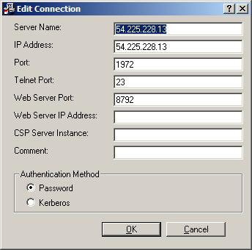

  - Log in via Cache’ Terminal
The Cache’ Terminal will connect directly to the programmer prompt in the VistA instance. No Access or Verify Codes are necessary. It is necessary, however, to change namespaces to the development namespace DEV1. It is also necessary to set the DUZ (user ID number) to 1.
Node: i665cpm1765, Instance: CACHE
CPRS>D ^%CD
Namespace: DEV1
You're in namespace DEV1
Default directory is d:\intersystems\cache\mgr\dev1\
DEV1>S DUZ=1
  - Log in via Attachmate Reflections
Attachmate Reflections is another method of logging into the VistA instance instead of using Cache’ Terminal. Create a new connection with these settings to log in. This also takes you directly to the programmer prompt, and the steps outlined above in section 2.2 for changing namespace and setting DUZ also apply.
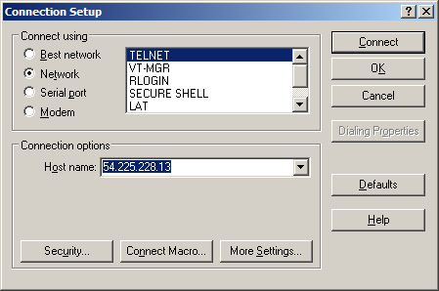
  - FTP of files
When necessary, transfer files for this innovation via FTP. Set the username and password both to vistaftp (case-sensitive). The default directory is d:\intersystems\cache\mgr\dev1\>
- Transfer of NDF Management System Files and Globals
Since no NDF Management System server was created, the approved workaround is to import the necessary NDF Management System files and globals into the VistA server. Files are transferred via FTP (see section 2.4 above).
  - Routines
The routines required from the NDF Management System are the PSSMIGR* routines:
PSSMIGR.INT PSSMIGRC.INT PSSMIGRD.INT PSSMIGRP.INT PSSMIGRR.INT
PSSMIGRS.INT
After being FTP’d to the VistA server, load the routines using the %RI utility.
  - Globals
The globals required from the NDF Management System are the ^DD, ^DIC, and ^NDFK files:
5000.1="EXTRA AUDIT"
5000.2="PRODUCTS TO UNMATCH"
5000.23="INTERACTION EXCLUSION/INCLUSION"
5000.3="GENERICS TO BE UNMATCHED"
5000.4="STRENGTH CHANGE"
5000.5="INDICATOR CHANGE"
5000.506="NEW VA PRODUCT NAMES"
5000.507="PRODUCT NAMES WITH CHANGED CLASS"
5000.508="INGREDIENTS ADDED"
5000.509="INGREDIENTS DELETED"
5000.56="NEW INTERACTIONS"
5000.6="PMI UPDATE LOG"
5000.608="OVERRIDE CHANGES"
5000.7="UNMARKED FOR CMOP"
5000.8="CLASS CHANGES"
5000.9="PRODUCTS WITH SCHEDULE CHANGE"
5000.91="MED GUIDE CHANGES"
5000.92="POSSIBLE DOSAGE SETTING CHANGES"
5000.93="REDUCED COPAY SETTING CHANGES"
5000.991="DATA FOR VUID"
5000.992="VUID MAP"
After being FTP’d to the VistA server, load the globals using the %GIGEN utility.
  - Remote order checks are disabled by editing routines PSJOC and PSIVEDT. Comment out lines or enter a QUIT so the functionality is not performed. Remote order checks are not active on this VistA server, and it was causing a system error and crash when attempting to place an Inpatient Medications order to test the functionality.
- VistALink Setup
  - New RPC for the innovation
The new RPC to attach to VistALink is created via Fileman to the REMOTE PROCEDURE File (#8994).

NUMBER: 3166 NAME: PPS NDFMS SYNC
TAG: SYNC ROUTINE: PSSMIGRC
RETURN VALUE TYPE: SINGLE VALUE AVAILABILITY: PUBLIC
INACTIVE: ACTIVE APP PROXY ALLOWED: Yes
INPUT PARAMETER: XML PARAMETER TYPE: REFERENCE
MAXIMUM DATA LENGTH: 32000 REQUIRED: YES
  - The new RPC is added via Fileman to the XOBV VISTALINK TESTER option in the OPTION File (#19).

NAME: XOBV VISTALINK TESTER MENU TEXT: VistALink Tester
TYPE: Broker (Client/Server) CREATOR: HSED,KAM
PACKAGE: VISTALINK
DESCRIPTION:
This option is the VistALink Tester application context.

This application is used to help developers learn how to use VistALink and help
site staff to test VistALink Listener ports.
TIMESTAMP OF PRIMARY MENU: 62944,54724
RPC: XOBV TEST GLOBAL ARRAY
RPC: XOBV TEST GLOBAL NODE
RPC: XOBV TEST LOCAL ARRAY
RPC: XOBV TEST PING
RPC: XOBV TEST RPC LIST
RPC: XOBV TEST STRING
RPC: XOBV TEST WORD PROCESSING
RPC: XOBV TEST XML RESULTS
RPC: XWB EGCHO SORT LIST
RPC: XWB GET VARIABLE VALUE
RPC: XOBV TEST MULTIPLE SUBSCRIPTS
RPC: XOBV TEST MULT ARRAY PARAMS
RPC: XOBV SYSTEMINFO
RPC: PPS NDFMS SYNC
UPPERCASE MENU TEXT: VISTALINK TESTER
  - The VistALink software comes with a pre-installed Application Proxy User, which is necessary for authentication of an outside user trying to connect to VistALink. For this innovation, this also serves as the Connector Proxy for VistALink. The User Class of Connector Proxy should be the only user class. For this to also serve its function as an Application Proxy, allowed to use the new RPC, the security key XUPROGMODE must be added. The user must also have the secondary menu option XOBV VISTALINK TESTER added.
NAME: XOBVTESTER,APPLICATION PROXY ACCESS CODE: <Hidden>
VERIFY CODE never expires: Yes
DATE VERIFY CODE LAST CHANGED: APR 30,2013
VERIFY CODE: <Hidden> DATE ENTERED: SEP 22, 2006
CREATOR: LABTECH,FORTYEIGHT
LAST SIGN-ON DATE/TIME: MAY 16, 2013@01:23:51
XUS Logon Attempt Count: 0 XUS Active User: Yes
Entry Last Edit Date: APR 30, 2013
NAME COMPONENTS: 200
SIGNATURE BLOCK PRINTED NAME: APPLICATION PROXY XOBVTESTER
KEY: XUPROGMODE GIVEN BY: PROGRAMMER,ONE
DATE GIVEN: APR 29, 2013
MULTIPLE SIGN-ON: ALLOWED
SECONDARY MENU OPTIONS: XOBV VISTALINK TESTER
TIMESTAMP: 62119,50719
User Class: CONNECTOR PROXY ISPRIMARY: Yes

  - A new VISTALINK CONFIGURATION, called HAZPHARM, is created. This serves as the instantiation of the VistALink listener for this innovation by setting the port number of the listener.

NUMBER: 2 NAME: HAZPHARM
PORT: 8001 STARTUP: YES

  - When the VistALink listener is running properly, the FOUNDATIONS MANAGER appears as follows:
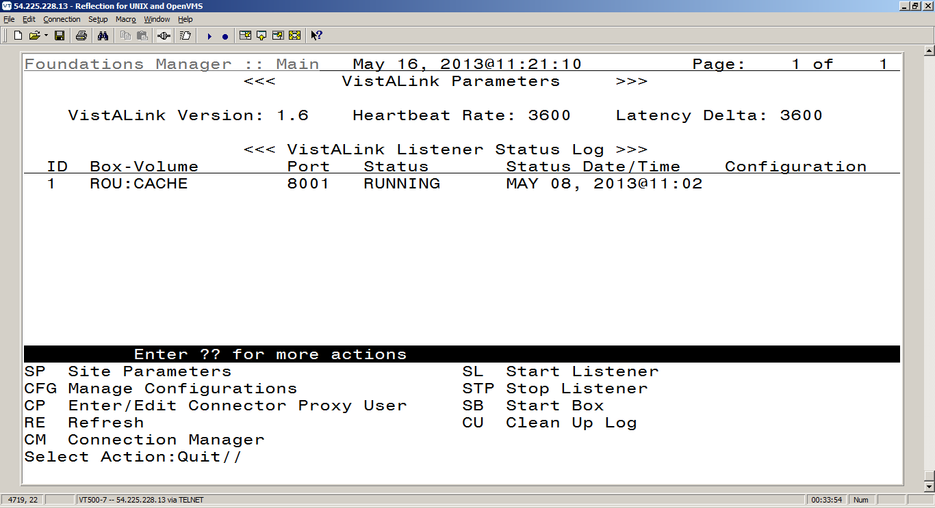

If there are connections to the VistALink listener, typing CM from the menu options shown above will appear as follows:
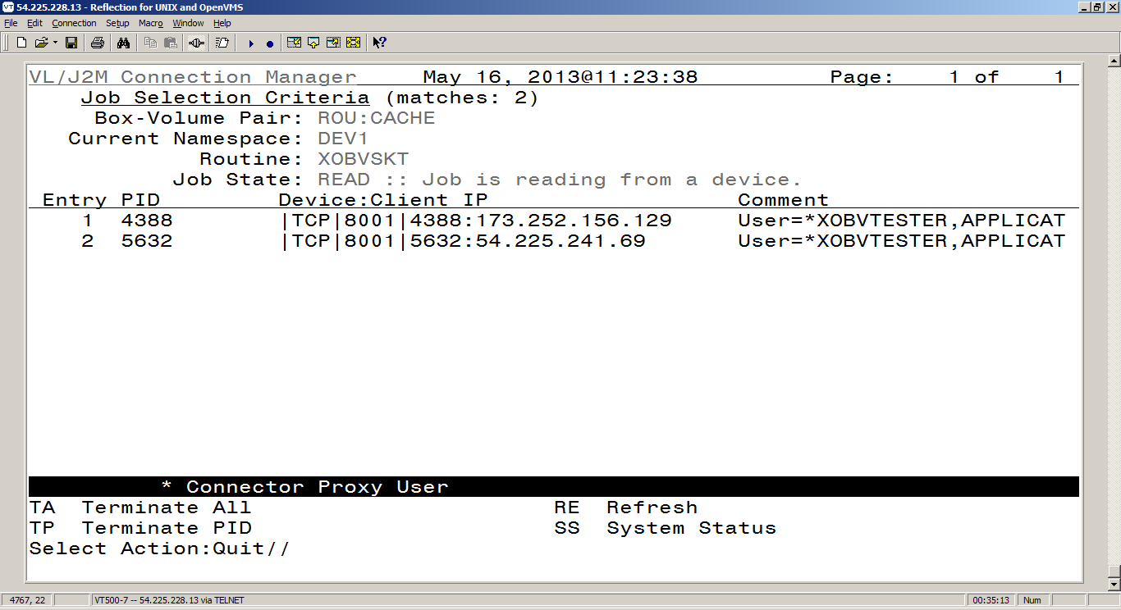

  - Users for PPS-N
Four users are set up to represent different levels of authorization to data in PPS-N. Their level of access is determined by the security key they hold. The users must have the User Class of Application Proxy, their appropriate security key, and XOBV VISTALINK TESTER as a secondary menu option. The four users set up are:

NAME: PPSN,MANAGER ACCESS CODE: <Hidden>
DATE VERIFY CODE LAST CHANGED: APR 10,2005
VERIFY CODE: <Hidden> DATE ENTERED: APR 09, 2013
CREATOR: PROGRAMMER,ONE
LAST SIGN-ON DATE/TIME: MAY 06, 2013@10:21:22
XUS Logon Attempt Count: 0 XUS Active User: Yes
Entry Last Edit Date: APR 09, 2013 TERMINAL TYPE LAST USED: C-VT320
NAME COMPONENTS: 200
SIGNATURE BLOCK PRINTED NAME: MANAGER PPSN
KEY: PSS_PPSN_MANAGER GIVEN BY: PROGRAMMER,ONE
DATE GIVEN: APR 09, 2013
PRIMARY MENU OPTION: EVE
SECONDARY MENU OPTIONS: XOBV VISTALINK TESTER
TIMESTAMP: 62945,33084
User Class: APPLICATION PROXY ISPRIMARY: Yes

NAME: PPSN,SECOND ACCESS CODE: <Hidden>
DATE VERIFY CODE LAST CHANGED: APR 10,2005
VERIFY CODE: <Hidden> DATE ENTERED: APR 09, 2013
CREATOR: PROGRAMMER,ONE
LAST SIGN-ON DATE/TIME: MAY 03, 2013@11:04:28
XUS Logon Attempt Count: 0 XUS Active User: Yes
Entry Last Edit Date: APR 09, 2013 NAME COMPONENTS: 200
SIGNATURE BLOCK PRINTED NAME: SECOND PPSN
KEY: PSS_PPSN_SECOND_APPROVER GIVEN BY: PROGRAMMER,ONE
DATE GIVEN: APR 09, 2013
PRIMARY MENU OPTION: EVE
SECONDARY MENU OPTIONS: XOBV VISTALINK TESTER
TIMESTAMP: 62945,33053
User Class: APPLICATION PROXY ISPRIMARY: Yes

NAME: PPSN,SUPERVISOR ACCESS CODE: <Hidden>
DATE VERIFY CODE LAST CHANGED: APR 10,2005
VERIFY CODE: <Hidden> DATE ENTERED: APR 09, 2013
CREATOR: PROGRAMMER,ONE
LAST SIGN-ON DATE/TIME: MAY 07, 2013@16:31:34
XUS Logon Attempt Count: 0 XUS Active User: Yes
Entry Last Edit Date: MAY 01, 2013 TERMINAL TYPE LAST USED: C-VT102
NAME COMPONENTS: 200
SIGNATURE BLOCK PRINTED NAME: SUPERVISOR PPSN
KEY: PSS_PPSN_SUPERVISOR GIVEN BY: PROGRAMMER,ONE
DATE GIVEN: APR 09, 2013
PRIMARY MENU OPTION: EVE
SECONDARY MENU OPTIONS: XOBV VISTALINK TESTER
TIMESTAMP: 62945,33022
User Class: APPLICATION PROXY ISPRIMARY: Yes

NAME: PPSN,VIEWER ACCESS CODE: <Hidden>
DATE VERIFY CODE LAST CHANGED: APR 10,2005
VERIFY CODE: <Hidden> DATE ENTERED: APR 09, 2013
CREATOR: PROGRAMMER,ONE
LAST SIGN-ON DATE/TIME: MAY 06, 2013@15:20:05
XUS Logon Attempt Count: 0 XUS Active User: No
Entry Last Edit Date: APR 09, 2013 NAME COMPONENTS: 200
SIGNATURE BLOCK PRINTED NAME: VIEWER PPSN
KEY: PSS_PPSN_VIEWER GIVEN BY: PROGRAMMER,ONE
DATE GIVEN: APR 09, 2013
PRIMARY MENU OPTION: EVE
SECONDARY MENU OPTIONS: XOBV VISTALINK TESTER
TIMESTAMP: 62945,33103
User Class: APPLICATION PROXY ISPRIMARY: Yes
- Connection to BCMA
The connection to BCMA is established through existing Remote Procedures and the RPC Broker. Apart from starting the RPC Broker, no further setup or configuration is necessary to establish communication between VistA and BCMA.
Section 5: Installation of BCMA Modifications Environment

The Barcode Medication Administration (BCMA) program is used to identify the patient and to identify the medication administrations intended for the patient at a given time. It operates via a combination of M-code routines running on a Cache server and a Delphi-based client which calls the M routines on the Cache server via remote procedure calls (RPCs).

Pre-Installation Information
Before installing BCMA V. 3.0, make sure that your system includes the following Department of Veterans Affairs (VA) software packages and versions (those listed or higher).
Packages Required | Minimum Version Needed
Inpatient Medications | 5.0
Kernel | 8.0
MailMan | 8.0
Nursing | 4.0
Order Entry/Results Reporting | 3.0
Pharmacy Data Management | 1.0
RPC Broker (32-bit) | 1.1
Toolkit | 7.3
VA FileMan | 22.0
Vitals/Measurements | 5.0

Installation Time Estimates
On average, it takes approximately two minutes to install BCMA V. 3.0. This estimate was provided by a few of our BCMA V. 3.0 Beta Test sites. Actual times may vary, depending on how your site is using its’ system resources.
The suggested time to install is during non-peak requirement hours. During the install process, PC Client users should not be accessing the Client Software.

Resource Requirements
This section summarizes the (approximate) number of resources required to install BCMA V. 3.0.
- Routines 60
- Globals 1 (^PSB)
- Files 5 (53.66-53.79)
- ^PSB Size Unit Dose = 300 x # of Medications (in bytes) Administered IV = 2100 x # of IV Bags Administered
- FTEE Support .2
- FTEE Maintenance .2

Response Time Monitor
BCMA V. 3.0 does not include Response Time Monitor hooks.

Laptops and Bar Code Scanners
The approximate requirements for laptops and bar code scanners depend on the number of Inpatient areas, at your site, that use BCMA V. 3.0 for administering active medication orders. The BCMA Development Team recommends that your site have a minimum of three laptops and three scanners for each ward.

Printers
Your site should provide printers for creating patient wristbands and medication bar code labels, and for handling Missing Dose Requests sent from BCMA V. 3.0 to the Pharmacy.

Unit Dose Label Printer Devices
BCMA V. 3.0 includes the Label print [PSBO BL] option for printing individual or batch Unit Dose bar code labels. It is specifically coded to the Zebra-brand printers using the Zebra Programming Language (ZPL). Model 105SE was used in the development of the labels. Routine PSBO BL uses site-specific printers or terminals to produce labels.

IV Label Printer Devices
Inpatient Medications V. 5.0 provides a menu option for printing individual or batch IV bar code labels. See the section “Interfacing with the Bar Code Label Printer” in the Inpatient Medications V. 5.0 Technical Manual/Security Guide for detailed setup information.

Client PC Setup Requirements
Once all BCMA V. 3.0 files are installed, make sure that every Client PC includes the minimum system configuration and Broker patch, XWB*1.1*29 (Shared Broker), before users run BCMA V. 3.0 from it. BCMA and the Shared Broker must be installed via an account that has Administrative privileges.
For specific Client PC Setup Requirements, see the “VA Standard Desktop Configurations” link below, which provides the current corporate software and hardware configurations per VA Directive 6401.
http://vaww.vairm.vaco.va.gov/vadesktop/default.htm

Files Required to Run BCMA V. 3.0
BCMA V. 3.0 uses the following files installed on the VISTA Server. “Journaling” is recommended.
- ^PSB (53.66, BCMA IV Parameters
- ^PSB (53.68, BCMA Missing Dose Request
- ^PSB (53.69, BCMA Report Request
- ^PSB (53.78, BCMA Medication Variance Log
- ^PSB (53.79, BCMA Medication Log

Note: You can learn more about these files by generating a list with file attributes using VA FileMan.

Routines Installed
Review the listing below to learn the routines installed on to your site’s VISTA Server during the installation of BCMA V. 3.0. The first line of each routine briefly describes its general function.
Note: You can use the Kernel First Line Routine Print [XU FIRST LINE PRINT] option to print a list containing the first line of each PSB routine.

Routine Mapping
At this time, we do not offer any recommendations for routine mapping. However, if you choose to map the BCMA V. 3.0 package routines, you will need to bring your system down, and then restart it to load the new routines into memory.

Example: BCMA V. 3.0 Routines Installed on to VISTA Server

PSBALL PSBAPIPM PSBCHIVH PSBCHKIV PSBMD PSBML PSBML1 PSBMLEN
PSBMLEN1 PSBMLHS PSBMLTS PSBMLU PSBMLVAL PSBO PSBO1 PSBOAL
PSBOBL PSBODL PSBODL1 PSBODO PSBOHDR PSBOMD PSBOMH PSBOMH1
PSBOMH2 PSBOML PSBOMM PSBOMV PSBOPE PSBOPI PSBOPM PSBOVT
PSBOWA PSBPAR PSBPARIV PSBPOIV PSBPRN PSBRPC PSBRPC1 PSBRPC2
PSBRPC3 PSBRPCMO PSBRPCXM PSBSAGG PSBSVHL7 PSBUTL PSBVAR PSBVDLIV
PSBVDLPA PSBVDLPB PSBVDLTB PSBVDLU1 PSBVDLU2 PSBVDLU3 PSBVDLUD PSBVDLVL
PSBVITFL PSBVT PSBVT1 PSBXMRG
60 routines

Routines with Related Checksums
This section lists the routines and related checksums for BCMA V. 3.0 provided during the installation process.
Example: BCMA V. 3.0 Routines with Related Checksums

Select BUILD NAME: PSB 3.0 BAR CODE MED ADMIN

PSBALL value = 1475151
PSBAPIPM value = 9031085
PSBCHIVH value = 1166996
PSBCHKIV value = 35513271
PSBMD value = 17319681
PSBML value = 23421797
PSBML1 value = 7074072
PSBMLEN value = 18077803
PSBMLEN1 value = 9220985
PSBMLHS value = 2525483
PSBMLTS value = 8100734
PSBMLU value = 1498988
PSBMLVAL value = 9734944
PSBO value = 17926200
PSBO1 value = 2876667
PSBOAL value = 1806300
PSBOBL value = 4045534
PSBODL value = 16589922
PSBODL1 value = 8836828
PSBODO value = 2948451
PSBOHDR value = 5286664
PSBOMD value = 6143174
PSBOMH value = 20105393
PSBOMH1 value = 20721307
PSBOMH2 value = 9443664
PSBOML value = 10399745
PSBOMM value = 21442785
PSBOMV value = 13276146
PSBOPE value = 7022505
PSBOPI value = 288600
PSBOPM value = 4855752
PSBOVT value = 790819
PSBOWA value = 13904863
PSBPAR value = 6032995
PSBPARIV value = 16437954
PSBPOIV value = 24363099
PSBPRN value = 7079605
PSBRPC value = 10743383
PSBRPC1 value = 5473533
PSBRPC2 value = 20110546
PSBRPC3 value = 194738
PSBRPCMO value = 18080428
PSBRPCXM value = 2728593
PSBSAGG value = 1431404
PSBSVHL7 value = 16217830
PSBUTL value = 14185290
PSBVAR value = 4760179
PSBVDLIV value = 17858201
PSBVDLPA value = 4059667
PSBVDLPB value = 19523684
PSBVDLTB value = 3557813
PSBVDLU1 value = 18022165
PSBVDLU2 value = 4610568
PSBVDLU3 value = 3001261
PSBVDLUD value = 18568646
PSBVDLVL value = 23162182
PSBVITFL value = 2483832
PSBVT value = 22976876
PSBVT1 value = 767427
PSBXMRG value = 1576759

VistA Server Installation

Perform the steps provided below to download BCMA V. 3.0 from an FTP Server. Then you will be ready to use this section for loading the Kernel Installation & Distribution System (KIDS) Distribution file and the Broker Server file, and for installing BCMA V. 3.0 on to the VISTA Server.
Attention: BCMA V. 3.0 includes a new GUI executable file. Installation of this GUI is NOT required immediately after the KIDS install for the software to function. The installation process will make significant changes to routines, files, and files within the BCMA V. 3.0 application. Review the bulleted list below, taken from the Build description, for more information.
- Prior clients compatible with BCMA V. 3.0: 2.0.36.14
- Client can be copied instead of installed: Yes

Installation Steps:
- Download BCMA V. 3.0 Software
Use the following information to download BCMA V. 3.0 from an FTP Server.
  - Download the GUI BCMA file PSB3_0.exe, the Host File PSB_3_0.KID from an FTP Server designated specifically for use in conjunction with the Hazardous Pharmaceuticals Prototype.
The preferred method is to “FTP” the files from the designated server housing the BCMA V. 3.0 for use in conjunction with the Hazardous Pharmaceuticals Prototype of the application.
- .EXE or .PDF files need to be FTP in BINARY.
- KIDS Build needs to be FTP in ASCII.
  - Move the files to the appropriate directory on your system.
- Load the KIDS Distribution File
Perform the steps listed below to load the KIDS Distribution file.
  - Sign in to the UCI where the KIDS Distribution file will be loaded and BCMA V. 3.0 will be installed.
  - At the “Select OPTION NAME:” prompt, type XPD MAIN and press ENTER.
  - At the “Select Kernel Installation & Distribution System Option:” prompt, type INSTALLation, and then press ENTER.
  - At the “Select Installation Option:” prompt, type Load a Distribution and press ENTER to prepare for loading the KIDS Distribution file.
  - At the “Enter a Host File:” prompt, type the directory where you have stored the Host File, followed by PSB_3_0.KID. Then press ENTER.
  - At the “Want to Continue with Load YES//?” prompt, press ENTER. The system then loads the file to this location.
- Install BCMA V. 3.0
Now you are ready to install BCMA V. 3.0 on to the VISTA Server. The suggested time to install is during non-peak requirement hours. During the install process, PC Client users should not be accessing the Client Software.
Note: You should perform step 3.1 listed below now if you are planning to install BCMA V. 3.0 immediately. However, if you are installing the application at another time, ask users to log off your system at that time.
  - From the Facility Tab of the GUI BCMA Site Parameters application, take BCMA users offline.
  - Request that all BCMA users log off BCMA.
  - Review mapped sets for PSB* namespaces. If the routines are mapped, remove them from the mapped set at this time.
  - Backup your system. This step is optional, but recommended.
  - At the “Select INSTALL NAME:” prompt, type PSB 3.0 and then press ENTER to install BCMA V. 3.0. This Build provides all of the routines and files necessary for BCMA V. 3.0.
  - At the “Want KIDS to Rebuild Menu Trees Upon Completion of Install? YES//” prompt, type NO, and then press ENTER.
  - At the “Want KIDS to INHIBIT LOGONs during the install? YES//” prompt, type NO, and then press ENTER.
  - At the “Want to DISABLE Scheduled Options, Menu Options, and Protocols? YES//” prompt, type NO, and then press ENTER.
  - At the “DEVICE:” prompt, press ENTER to use the default device HOME (the screen) for printing the Installation message. If you want to print a hard copy, enter your site printer, and then press ENTER.
  - If routines were unmapped as part of the installation process, return them to the mapped set once the installation of BCMA V. 3.0 is completed.
  - From the Facility Tab of the GUI BCMA Site Parameters application, place BCMA V. 3.0 back on-line.

Additional Preparation for BCMA V. 3.0
Now you are ready to perform the steps listed below to further prepare your site and staff for using BCMA V. 3.0.
Installation Steps:
- If you are a Micronectics Standard MUMPS (MSM) site, move the PSB routines only, to all nodes.
- Assign the following security keys to appropriate site personnel.
- PSB MANAGER – designates the holder as a manager
- PSB INSTRUCTOR – designates the holder as a nursing instructor supervising student nurses
- PSB STUDENT – designates the holder as a student nurse, requiring that an instructor also sign on to BCMA V. 3.0 at the same time
- PSB CPRS MED BUTTON – designates the holder as a nurse who can document administered verbal- and phone-type STAT and NOW orders using the CPRS Med Order Button on the BCMA V. 3.0 VDL.

Installing PSB*3*68T25 BCMA Client Prototype

The software distribution includes these modified files:

File Name | Description | File Version | Bytes | Checksum
BCMA.CHM | Client Help File |  | 1,065 KB | n/a
BCMA.EXE | Client | 3.0.68.25 | 2,487 KB | n/a
BCMAPar.CHM | Parameters Client Help |  | 143 KB | n/a
BCMApar.EXE | Parameters Client | 3.0.68.5 | 1.066 KB | n/a

- Prior client compatible with patch: NO
- Client can be copied instead of installed: YES
- Is your site running the CareFusion Wireless Medication Administration (WMA) software? If YES, please contact CareFusion to ensure your site has the latest compatible WMA patch.

Note: Use Binary mode to retrieve the .EXE file.

To obtain the updated .EXE, use FTP to retrieve PSB3_0P68T25.EXE (2,487 KB) from Open Source Electronic Health Agent OSEHRA.
If BCMA is currently running, please exit BCMA. This client installation patch file can be used to upgrade an existing version of BCMA, or can be used for a brand new installation.

- Double Click on PSB3_0P68T25.EXE which will launch the InstallShield Wizard.
- When the InstallShield Wizard Welcome screen is displayed, click "Next."
- On the Choose Destination Location screen, simply click "Next" If you would like to change the destination folder to one other than default, click "Browse" to navigate to the folder of your choice. Click "Next."
- On the "Setup Type" Screen select one of the following:
a. Typical - installs only the BCMA client program which is necessary for medication administration.
b. Complete - installs the BCMA client and the GUI BCMA site parameters definition program.
c. Custom - allows you to select which programs to install. Typical is selected by default. Click Next."
- The InstallShield Wizard Ready to Install the Program screen will display. Click "Install" to proceed with the installation.
- The InstallShield Wizard Complete screen will be displayed. Click "Finish" and the BCMA installation is now complete.

